prometheus download link - https://prometheus.io/download

grafana download link - https://grafana.com/grafana/download

Installing Prometheus

wget https://github.com/prometheus/prometheus/releases/download/v2.19.2/prometheus-2.19.2.linux-amd64.tar.gz

tar -xvf prometheus-2.19.2.linux-amd64.tar.gz

cd prometheus-2.19.2.linux-amd64

./prometheus

It can be accessed on ip:9090

metrics can be found in ip:9090/metrics

Install node exporter on the nodes you want to monitor

wget https://github.com/prometheus/node_exporter/releases/download/v1.0.1/node_exporter-1.0.1.linux-amd64.tar.gz

tar -xvf node_exporter-1.0.1.linux-amd64.tar.gz

cd node_exporter-1.0.1.linux-amd64

./node_exporter

edit the prometheus.yml

nano prometheus.yml

Paste the following

- job_name: 'node_exporter'

static_configs:

- targets: ['18.224.181.0:9100'] #add the ip of the nodes where node_exporter is installed

, you can even add multiple node ips like - targets: ['18.224.181.0:9100','9.224.181.0:9100','19.224.181.0:9100]

access using ip of node:9100

wget https://dl.grafana.com/oss/release/grafana-7.0.5.linux-amd64.tar.gz

tar -zxvf grafana-7.0.5.linux-amd64.tar.gz

[centos@ip-10-0-0-107 ~]$ cd grafana-7.0.5

[centos@ip-10-0-0-107 grafana-7.0.5]$ ./bin/grafana-server

Login into grafana

It can be accessed on ip:3000

uname:admin

pw:admin

Add data source->prometheus

Url: <http://ip:9090/>

Save and test

Create Import> Import via grafana.com

1860

405

11074

Load

Prometheus->Import

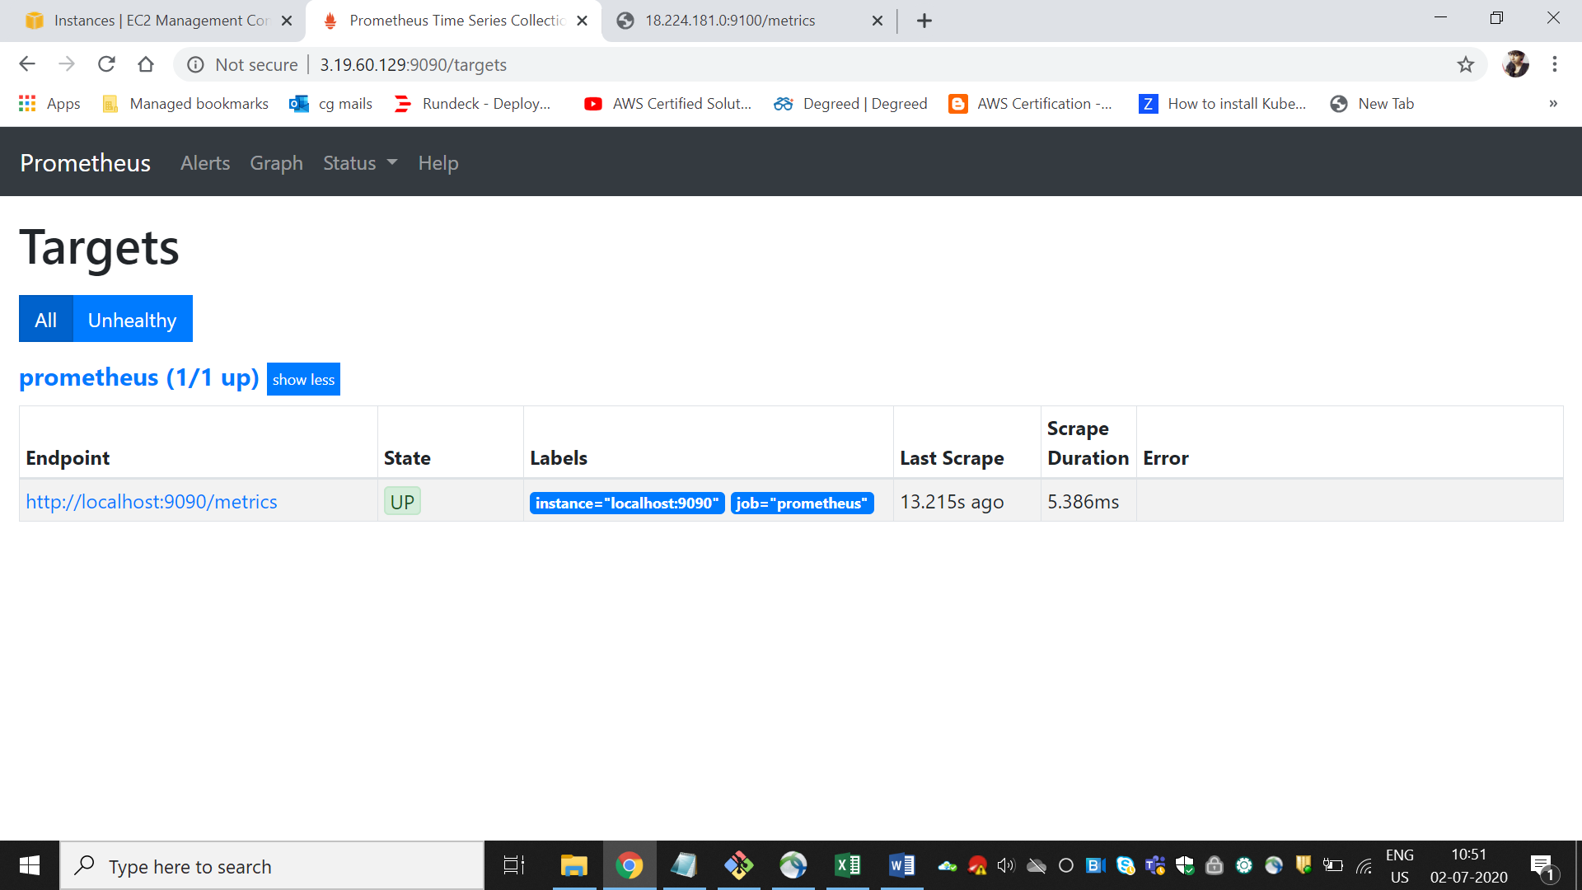

NodeExporter metrics

